Ec2 tasks

Launch one EC2 using Amazon Linux 2 image and add a script in user data to install Apache.
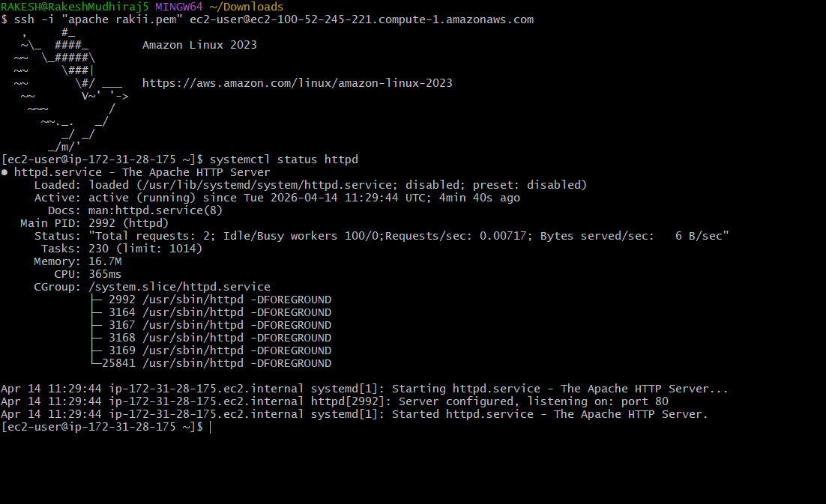
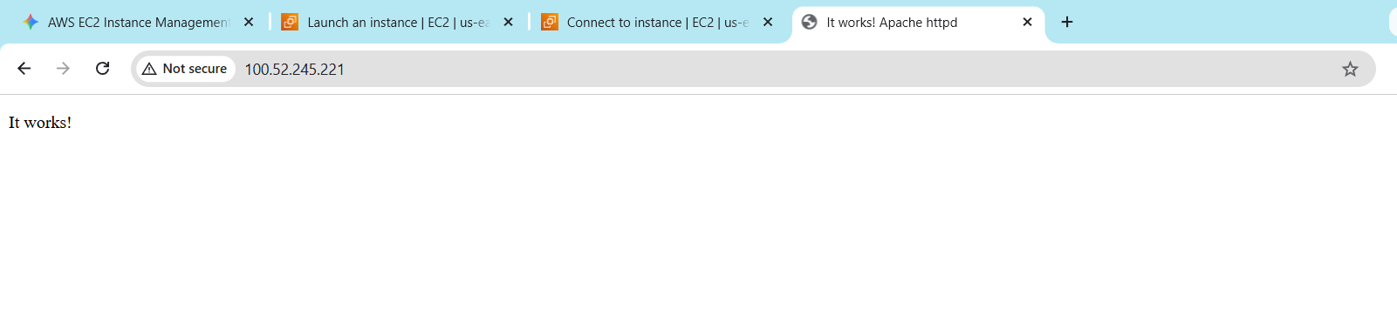

Launch one EC2 using Ubuntu image and add a script in user data to install Nginx.
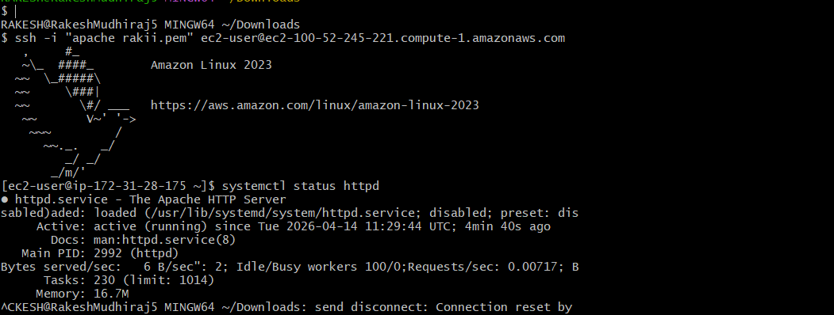
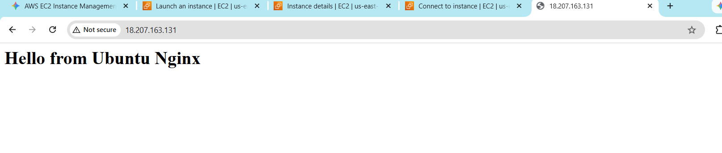

Launch one Windows server and install Tomcat on Windows.
- Connected to the Windows EC2 instance successfully
using Remote Desktop (RDP).
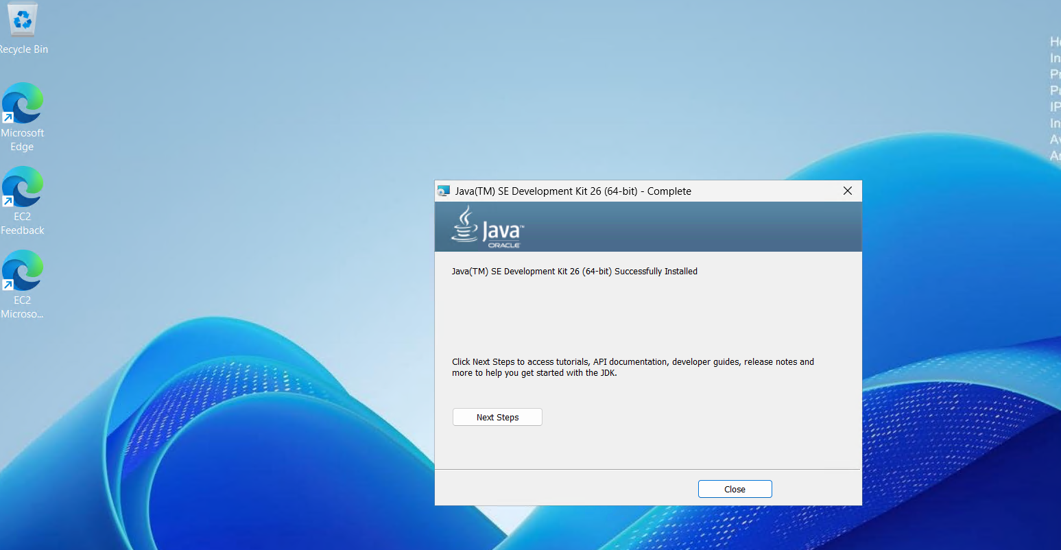

- Configured the JAVA_HOME environment variable by
setting the JDK installation path on the Windows server.

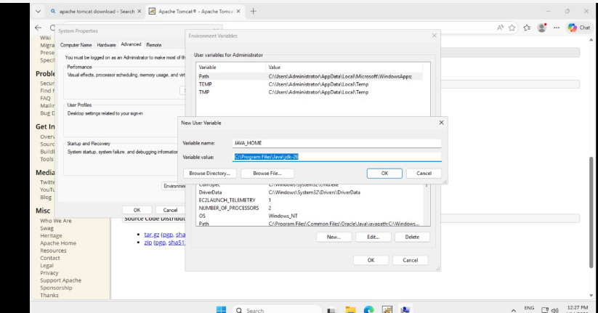
- Started Apache Tomcat on the Windows server and
verified the Tomcat default page was displayed
successfully in the browser.

Take a snapshot of the instance created in Task 1.
- Opened the Create Snapshot page, selected the Apache-
Server instance as the source, and proceeded to create
the snapshot.
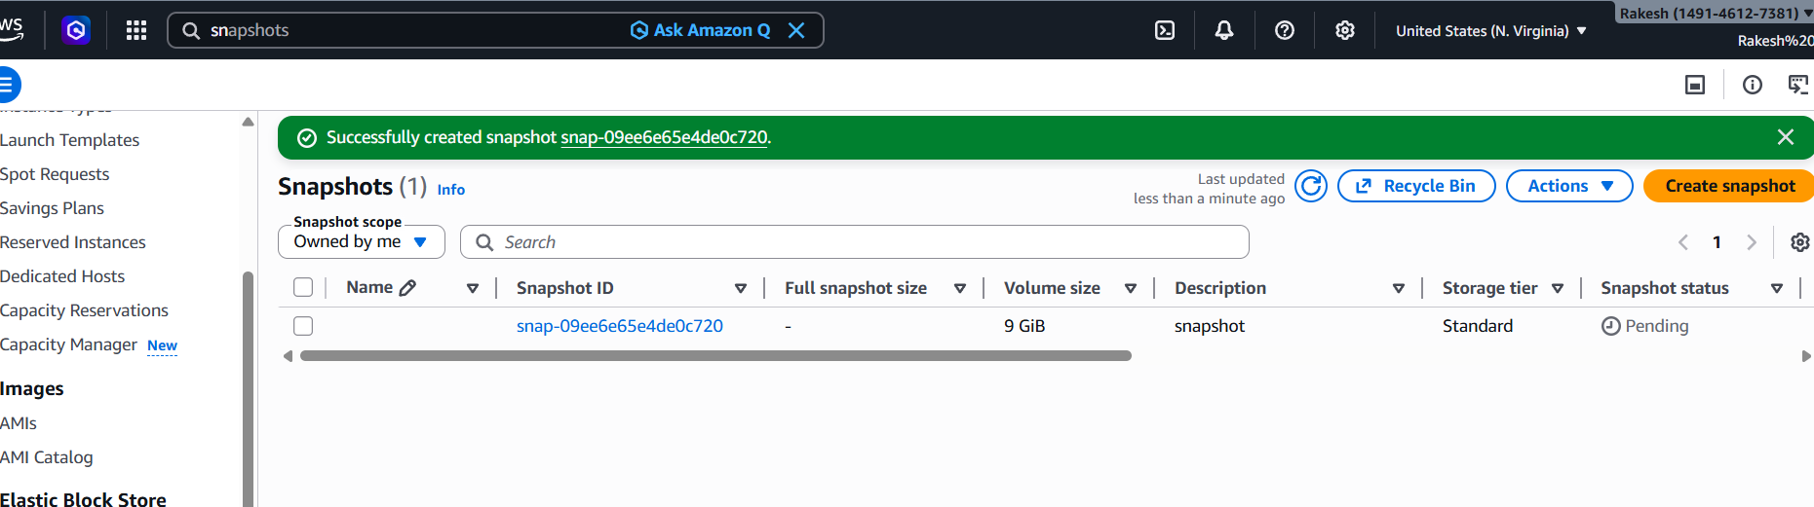

Assign passwordless authentication for the EC2 created in Task 2.
- Generated the SSH key pair using ssh-keygen, viewed the
public key, and prepared to configure passwordless
authentication for the EC2 instance.
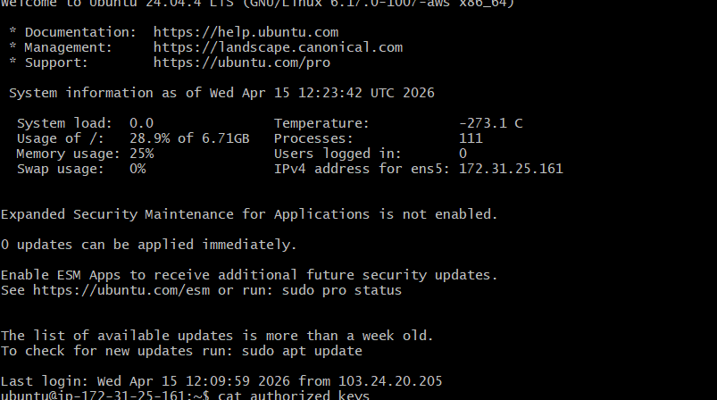
Launch any EC2 using the spot purchasing option.
- Selected the Spot purchasing option, configured the
maximum price and request settings, and proceeded to
launch the EC2 instance successfully.
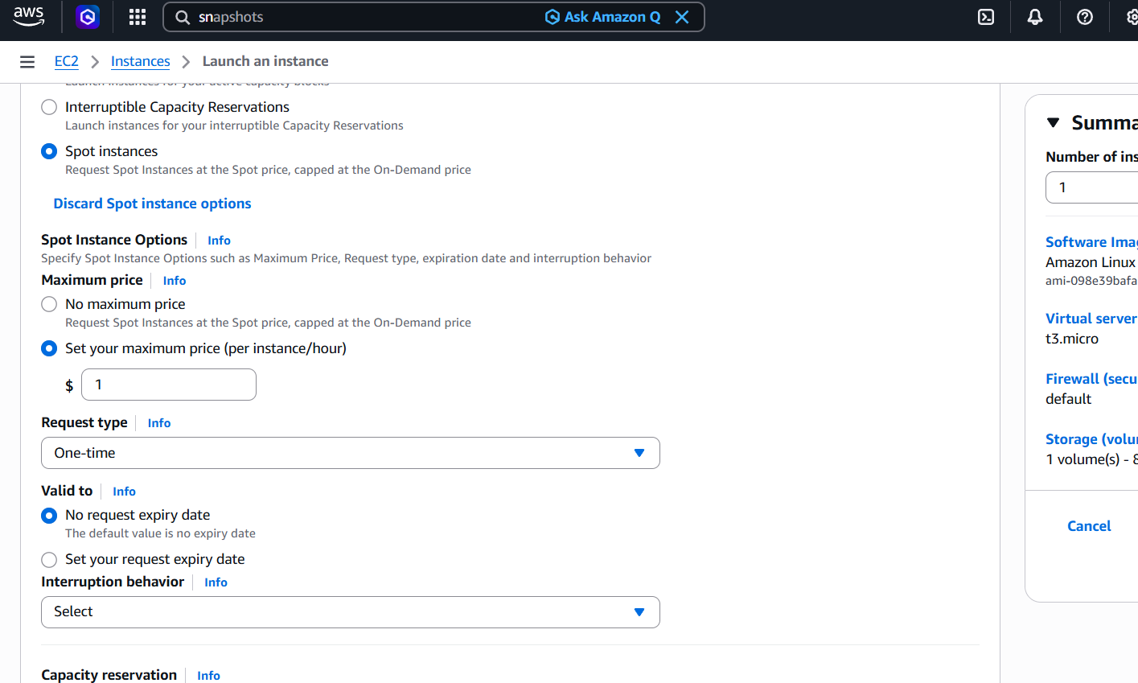

Enable termination policy on the EC2 created in Task 2.
- Opened the termination protection settings for the
Nginx-Server instance, enabled the option, and saved
the changes successfully.
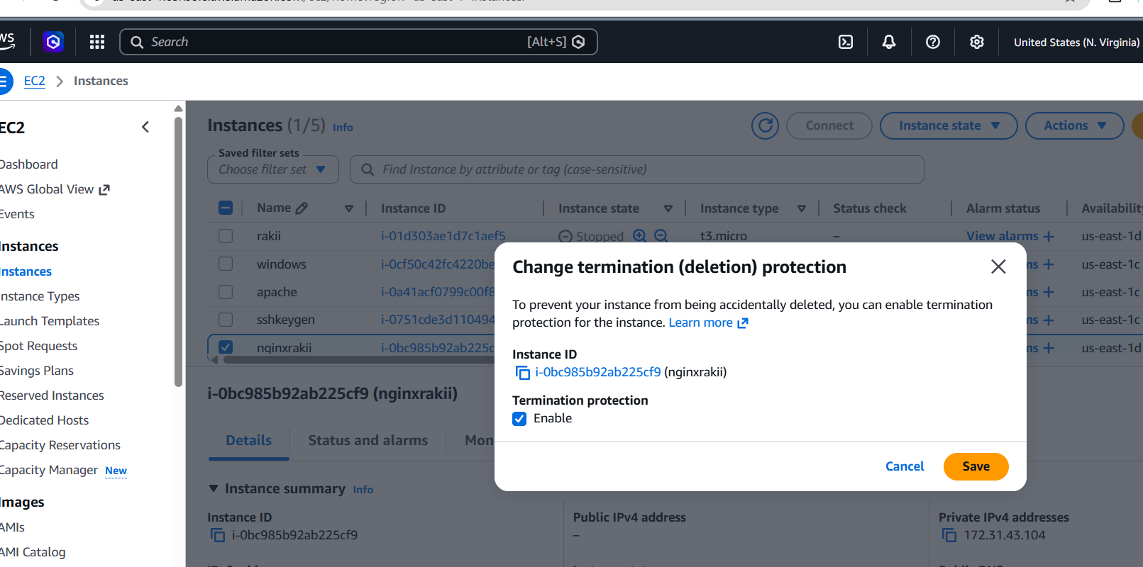
Launch one EC2 using AWS
